# **Project 1: Recreate and Remix**

1. Original S&P 500 candlestick chart taken from TradingView

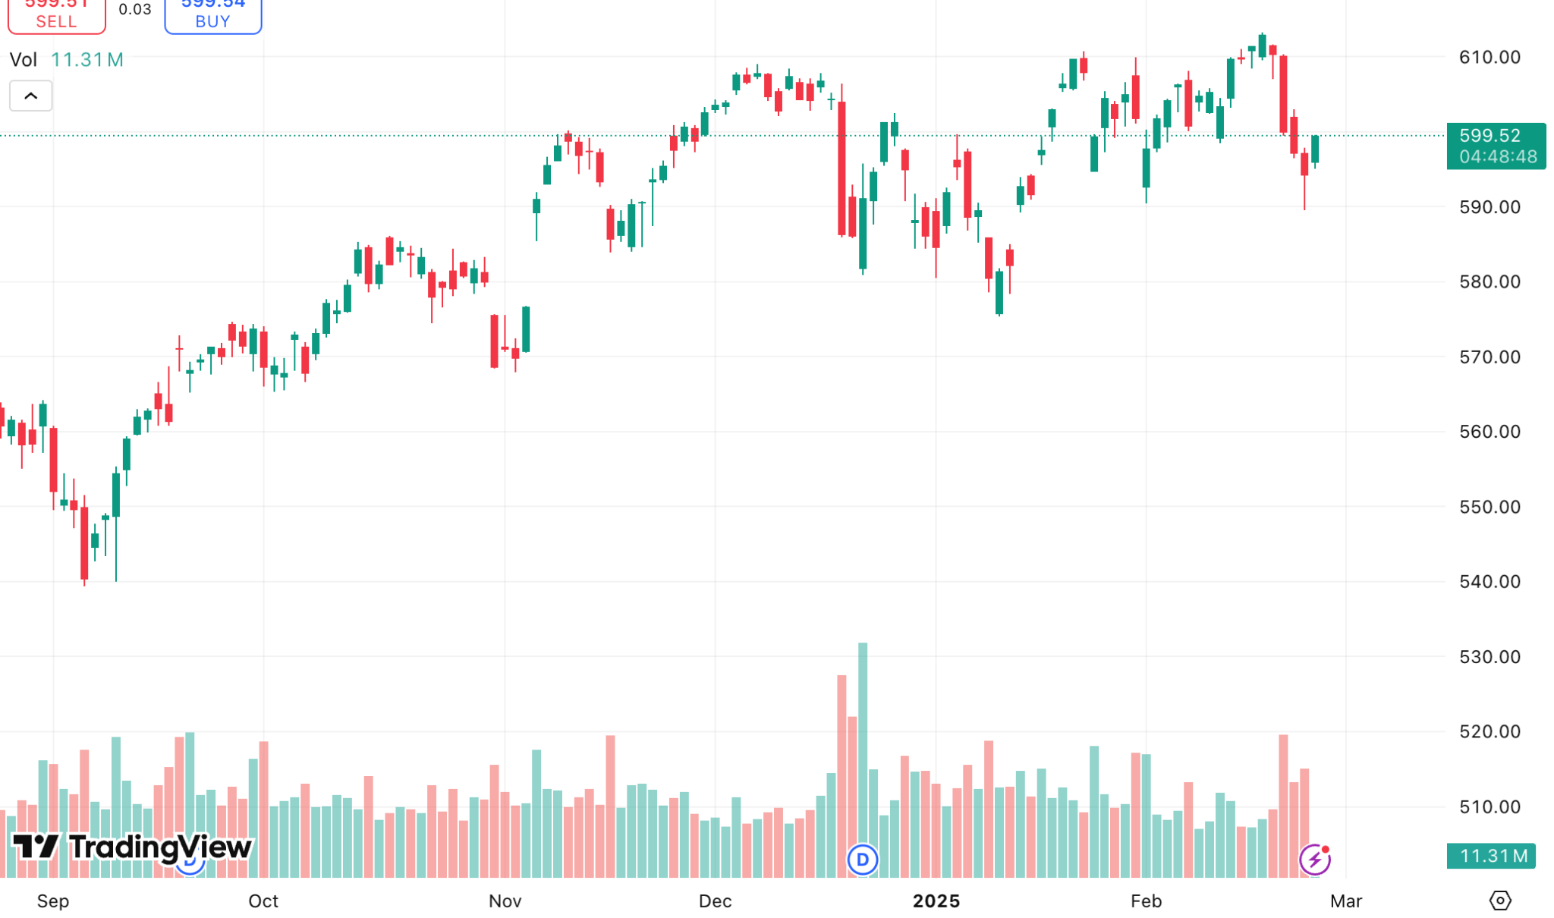

1. Recreation of the visualization

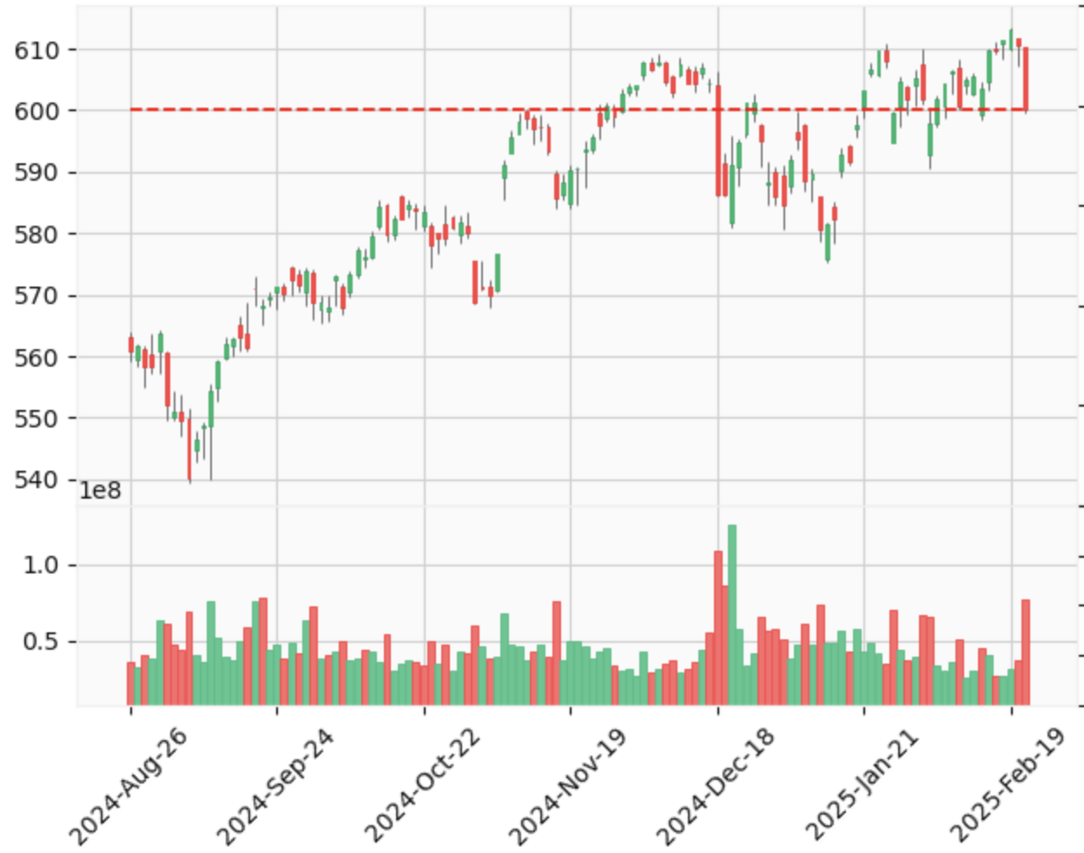

I wasn’t able to implement real-time data updates, including:

* **Real-time Bid and Ask prices** in the top left corner.
* **Real-time Volume** in the top left corner.
* **Time until market close** displayed on the right side, aligned with the current price.

These issues arose because I used downloaded (static) data instead of a live data feed. Additionally, since three days have passed since I created this graph, the original candlestick chart now includes three additional candles.

1. Remix of the visualization

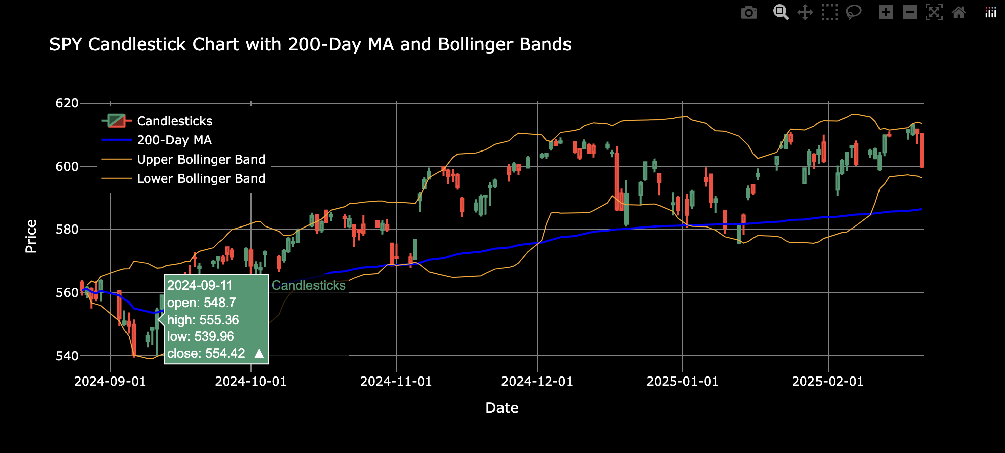

**Remix explanation:**

1. **Background Change** – I changed the background to black for better contrast and readability.
2. **200-Day Moving Average** – I added a 200-day moving average to show the overall trend of the chart.
3. **Bollinger Bands** – I included Bollinger Bands, which act as an indicator for potential overpricing or underpricing. Typically, when a candle breaks through the bands, we expect it to return within the range.
4. **OHLC Tooltip** – I added an option that displays the Open, High, Low, and Close (OHLC) prices for any selected candle when hovering over it.
5. **Interactive Features** – I enabled various Plotly navigation options, such as zooming in and out and selecting specific candles for better analysis.



I used ChatGPT and DeepSeek for assistance in developing this project.